Address line 1,
Address line 2,
Address line 3,
Address line 4,
Address line 5

Date

Dear Head Teacher

Kawasaki Disease School’s Information Pack

I am writing to ask if you would consider raising awareness of Kawasaki Disease within the school and to send you a Kawasaki Disease information pack which has been developed by Societi, the UK Foundation for Kawasaki Disease. I think you’d like to know about Kawasaki Disease - why? Because it’s a very serious children’s disease which is more common than measles and bacterial meningitis. Yet not many parents, carers or doctors know it. Kawasaki Disease is increasingly common in the UK and today it is the leading cause of acquired heart disease in children in the UK. Raising awareness of the disease is extremely important, as recognising the symptoms and treating early could save a child’s heart from life-long damage.

Little known but increasingly common, Kawasaki Disease presents with symptoms, many of which mirror those of other common childhood diseases such as Scarlet Fever. This can lead to misdiagnosis and a delay in treatment, which severely affects outcomes. In the UK, 39% of infants (children under one) develop coronary artery aneurysms - this is very serious heart damage and has been linked to delay in treatment. 28% of children overall suffer some heart damage after being affected by Kawasaki Disease. Heart damage may be avoided if treated early.

Kawasaki Disease has a range of symptoms including a characteristic and distinctively persistent high fever for five days or more and two or more of the symptoms opposite. Kawasaki Disease can be present with some or all of these symptoms. A persistent high fever is the one defining symptom which will always be present. The symptoms of Kawasaki Disease can also appear in series (i.e. not all at once) over a few days.

I have enclosed an information pack which I hope you will find helpful. You’ll find information leaflets to share with parents and general awareness posters suitable for display in your classrooms. The pack also includes a longer-term issues leaflet which provides helpful information to carers of children affected by Kawasaki Disease. If you have any questions, please do get in touch. If you’d like any further copies of the information provided in the pack, printable copies can be downloaded from the Societi website at www.societi.org.uk - or simply get in touch via their website or email info@societi.co.uk.

Thank you in advance for your help in raising awareness - it is so very important everyone knows Kawasaki Disease so that we can help protect our children’s hearts.

Yours sincerely,

Name Name,
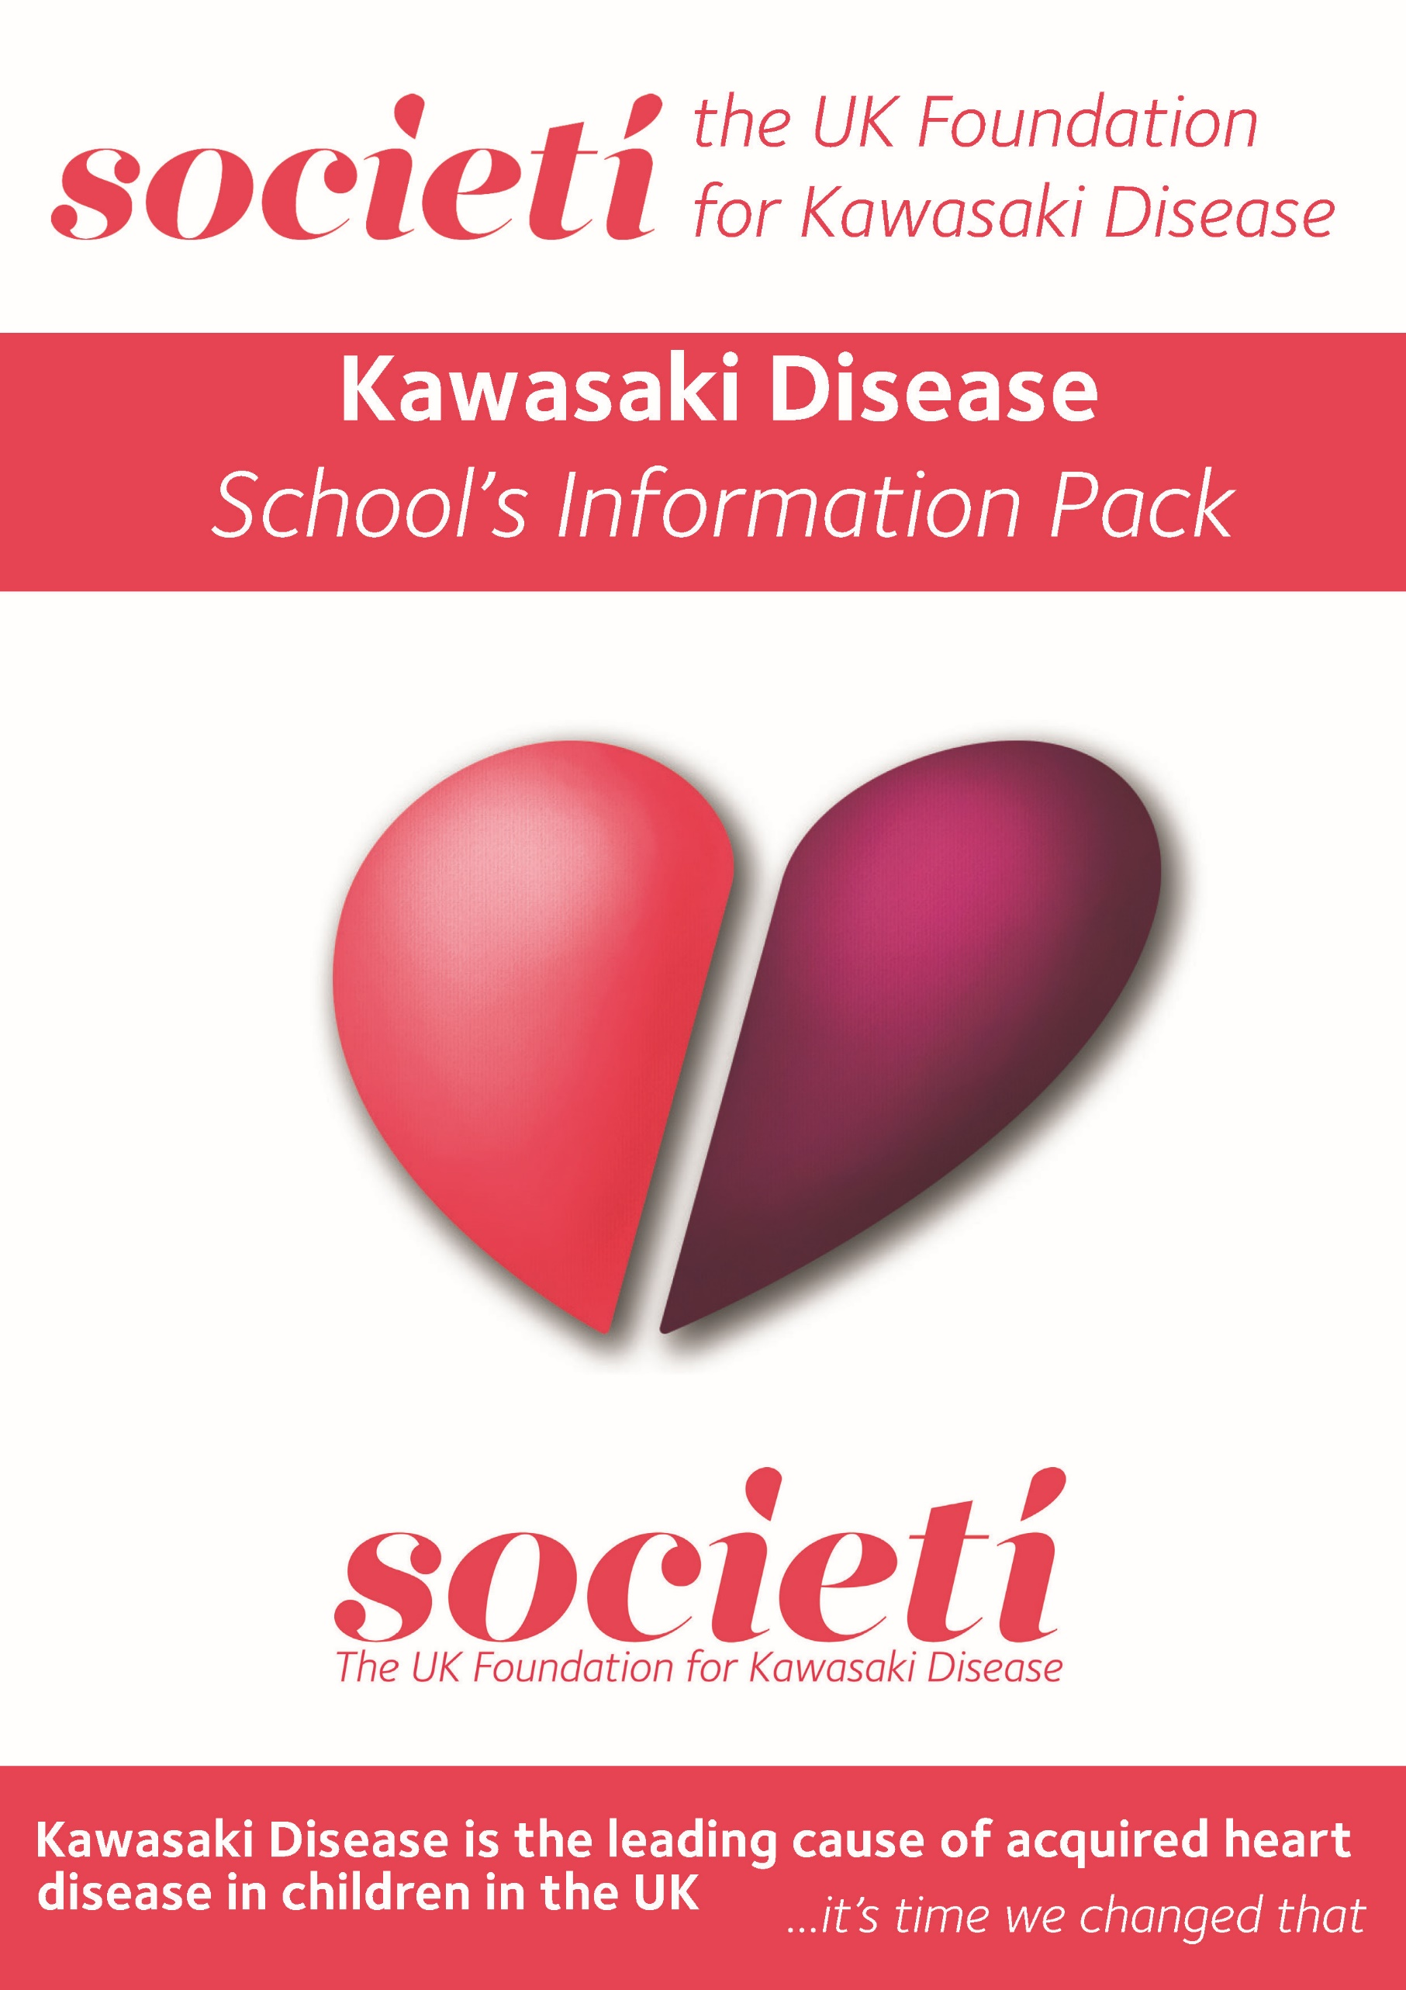
Enc. Kawasaki Disease School Information Pack
